Project Data Model and DB Design

Revised

Team 35

Yusuf Amer

Christina Nguyen Arman Sandher

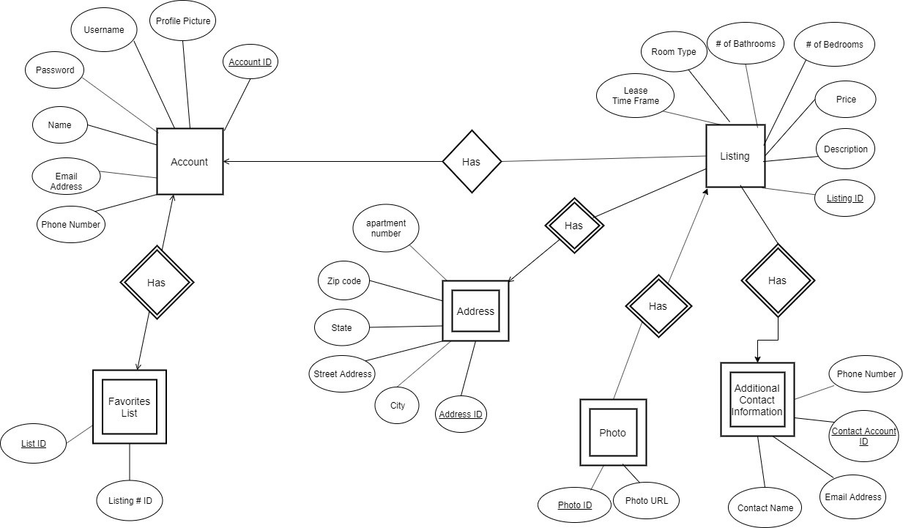

Entity Sets and Relationships Explanation:

Entity Set

* The Account entity set will be used for each user, whether a leaser or a renter. A unique Account ID will be used as the primary key for this entity set.
  + Accounts( accID, username, password, fullName, profilePicURL, email, phoneNum)
* The Listing entity set will be used for each post by a leaser for renters to be able to scroll through and search for a good fit. Every post will have its own Listing ID, which may be reused when a posting opens up again after a lease ends.
  + Listings(listingID, roomType, price, leaseTimeframe, roomNum, bathroomNum, description, photosID)
* The Favorites List entity set will be used as a weak entity set for each strong Account entity set, where a user prioritizes favorite listings posted. The list will have an id tied to it as the primary key and will use the Account entity’s primary key as a secondary key.
  + Favorites(listID, accID, listing1ID, listing2ID, listing3ID, listing4ID, listing5ID)
* The Photo entity set will be used for both the Listing entity set and the Account entity set, because each of those entity sets will need to provide pictures to help in identification. Each photo uploaded will have a unique Photo ID used as its primary key.
  + Photos(photoID, listingID, photoURL)
* The Additional Contact Information entity set will be used as a weak entity set for each strong Listing entity set, where a leaser can choose to add several other people to contact for inquiries or more information about the Listing posted.
  + AdditionalContacts(contactAccID, listingID, phoneNum, email, name)
* The Address entity will be used as a weak entity for each strong Listing Entity. Each listing entity will have 1 address, but multiple addresses can be used for different listings, such as different rooms for a single house.
  + Addresses(addrID, listingID, streetAddress, city, state, zipCode)

Relationship

* Each Listing has an Account that created it, and every Account will have 0 or more Listings created by it.
  + Account_Listings(listing_id, user_id)
* Each Favorites List belongs to an Account, and every account will have 0 or 1 Favorites List to prioritize posts.
  + User_Favorites(user_id, list_id)
* Each Listing has 0 or more Photos, and each Photo exists on 1 Listing.
  + Listings_Photos(photo_id, listing_id)
* Each Listing can have 0 or more additional Contact Information, and each piece of Contact information belongs to 1 or more Listings.
  + Listings_AdditionalContact(listing_id, addContact_id)
* Each listing has exactly 1 address tied to it, and every address can be tied to 0 or more Listings.

Listing_Address(listing_id, addr_id)

Sample Tables:

